**Abstract**

Recent literature has explored the development of the brain’s ventricular system as well as the role of cerebrospinal fluid (CSF). CSF nourishes the brain via signaling mechanisms and directs the removal of toxic metabolic products. Given the flow of CSF through the lateral ventricles (LV), LV size is an index of CSF production and turnover. Deviations in LV size relative to typical development may be reflective of aberrant CSF flow, which we hypothesize to be associated with various neurodevelopmental disorders. The goal of the current study was to determine if differences in LV volumes exist within the following diagnostic groups: autism spectrum disorder (ASD) and fragile X syndrome (FXS), relative to typically developing (TD) children.

We developed an anatomic protocol through the ITK-SNAP software to trace and quantify LV volumes on T1- and T2-weighted MRI images. After ensuring high intra- and inter-rater reliability, 146 cases (n=48 ASD, n=51 FXS, n=47 TD) were segmented and analyzed (ages 3-14 years). A logarithmic transformation of a linear model was used to test for group differences, while controlling for age and total cerebral volume (TCV). Results reached significance, suggesting that diagnostic group had a significant effect on LV volumes (F2,137=8.83,p<0.001). The FXS group had larger LV volumes relative to other diagnostic groups (95% CI = 14.6% to 77.2%). There was no significant difference in LV volumes in the ASD group compared to the TD group (95% CI = -25.3% to 16.4%).

These findings highlight the potential diagnostic value of neuroanatomical markers, which may pave the way for earlier and more effective intervention for individuals affected by these neurodevelopmental disorders.

**Introduction**

The relationship between neuroanatomy and neurodevelopmental abnormalities has emerged as an area of increasing interest. However, few prior studies have investigated broader associations between lateral ventricle (LV) volumes and diagnoses of neurodevelopmental disorders, such as autism spectrum disorder (ASD) or fragile X syndrome (FXS), while comparing to typically developing (TD) children. There is limited existing literature that conducts a comprehensive analysis of LV volumes across multiple developmental disorder diagnoses. Insight into the aberrant growth of the brain with specific biomarkers can potentially give clinicians and diagnosticians the ability to identify and care for patients in more effective ways.

One area of focus is the ventricular system of the brain. It is comprised of cerebrospinal fluid (CSF), the choroid plexus, and the ventricles. The main functions of CSF circulation are delivery of growth factors, nutrients, and peptides necessary for maintaining neuronal health, removal of neurotoxins and metabolic waste products, and cushioning of the brain against trauma.[1] CSF is known to interact with the apical progenitor cells on the lateral ventricle surface and provide cells with survival and growth cues.[2]

Typical CSF production levels range from 0.3 – 0.6 mL/min and a turnover rate of four times per day is considered normal. At any given time in an adult, there are 150 mL of CSF, with 25% of that volume contained within the ventricles and 75% within the subarachnoid space. Thus, one method to assess the state of the ventricular system is through LV size, which is a direct reflection of CSF production.1 Deviation from typical levels of CSF production, represented either through an enlargement or reduction or asymmetry in LV volumes, has been reported in multiple neurodevelopmental disorders and may have implications for behavioral deficits.1 We chose to explore the LVs for two reasons. First, the lateral ventricles are the largest of the four ventricles and, therefore, serve as a proxy to represent the size of the ventricular system as a whole. Second, they house the choroid plexus, which has the essential role of CSF production. Further exploration of the subject matter may elucidate new opportunities for understanding the link between altered LV size and specific functioning capacities of the brain.

ASD is a neurodevelopmental disorder primarily characterized by social deficits, compromised communication, and repetitive and restrictive behaviors.[3] The condition is diagnosed in 1 in every 68 children.[4] Current literature suggests that there is a strong neurobiological component, including excessive cortical white and gray matter growth; though the definitive etiology of ASD is still not fully understood.[5] Using MRI, researchers found subtle regional abnormalities and localized reductions in the occipital and frontal horns of the LVs in children with ASD.5 As such, we predict that the LVs of children with ASD to be similar or mildly reduced compared to their TD counterparts.

FXS is characterized as the most common X-linked developmental impairment, affecting approximately 1 in 5,000 children. Individuals with FXS tend to have deficits in physical development as well as cognitive and behavioral capacities.[6] FXS patients are reported to have decreased gray matter and increased white matter as well as significantly larger volumes of the caudate nucleus, thalamus, and ventricular CSF.[7] As such, we predict the FXS group to demonstrate overall increased LV volumes relative to TD and other diagnostic groups.

The purpose of this study is to identify differences in LV volumes in school-age children and to determine if these differences pose any diagnostic implications. To date, much of the existing research places a focus on neurodevelopmental differences in infants. This study adds to the landscape of current literature by quantifying and directly comparing neuroanatomical structures in children with FXS and ASD to their TD peers. To the best of our knowledge, this is the first study to do so and may ultimately allow for neuroanatomical markers to influence the timeframe of diagnosis, management, and health outcomes for families affected by these conditions.

**Methods:**

I. Sample

Participants were recruited through research registries and clinical referrals as part of a collaboration between the University of North Carolina and Stanford seeking to understand developmental disorders in school-aged children **(approved under IRB #?)**. A total of 249 LV volumes were quantified on 249 scans between UNC and Stanford. 42 of these scans were longitudinal and consequently excluded so that we could conduct a cross-sectional study. The AS group (n=23) was excluded because the group was significantly younger than the other groups by 3 years (p<.0001). Females were also excluded because the ASD, FXS, and TD diagnosis groups only consisted of males. Intellectual Disability (ID: n=4) and Unspecified Neurodevelopmental Disorder (UND; n=9) were excluded because they were too small of groups to analyze on their own. Other cases were excluded if the clinical diagnosis was unclear or if the MRI was not reliable. The FXS group included 42 children who had a diagnosis of FXS and ASD and 9 children who had FXS with no ASD. The high comorbidity of ASD in FXS is estimated at 15% to 60%, which is why they were included in the same group in this study.[8] The final analysis consisted of 51 school-aged children in the FXS group, 48 in the ASD group, and 47 in the TD group, totaling a sample size of 146. The average age was 9.78 (SD = 3.18) in the FXS group, 10.31 (SD = 2.99) in the ASD group, and 9.00 (SD = 2.81) in the TD group.

II. Image Processing

A training protocol was created in order to standardize the process of lateral ventricle tracing using ITK-SNAP program.[9] The tracing was completed through a combined image of the CSF (cerebrospinal fluid) probability image with an overlay of the T1-weighted image. Manual edits were made upon completion of the automatic segmentation. Continuing in the coronal view and going slice by slice, any voxels that appeared to be bright white (as opposed to grey) on the CSF probability image were manually filled in using the Paintbrush Mode tool with a brush size of 1 mm3. Any voxels that bled into regions other than the lateral ventricles, such as the third ventricle or hippocampus, were manually deleted. The temporal horns were not included in the volumetric tracing. Final segmentation results were overlaid on the T1-weighted image and reviewed for anatomical accuracy. Each colored voxel was 1 mm3. The total LV volume was calculated as the number of highlighted voxels and converted into cm3.

After analysis of the reliability series, both the intra-rater and inter-rater reliability were determined to have an ICC >0.99. See Figure 1 for images from ITK-SNAP representing segmentations for each diagnostic group.

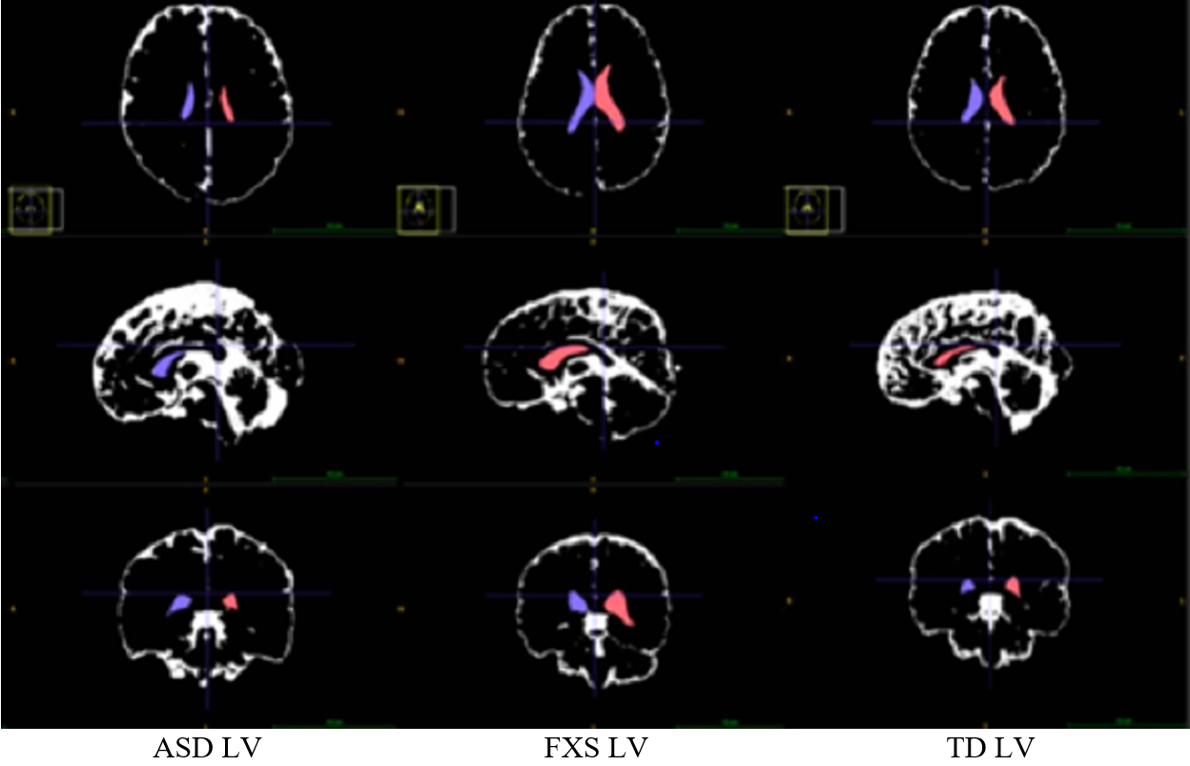

**Figure 1:** Sample images from ITK-SNAP of axial, sagittal, and coronal slices with segmented lateral ventricles of school-aged children with ASD, FXS, and a TD child. The blue color represents the right LV, and the red represents the left LV. Total LV was calculated as the sum of the left and right LV.

III. Clinical Assessment

Diagnoses were made by a licensed psychologist at the University of North Carolina that reviewed each case and its associated supporting materials. The Autism Diagnostic Observation Schedule (ADOS) and Autism Diagnosis Interview (ADI) were the two behavioral measures that were used during the 2-hour in-person assessment. Supporting materials included forms such as the Repetitive Behavior Scale-Revised (RBS-R) and the Sensory Experiences Questionnaire (SEQ) that were filled out by parents regarding behaviors and preferences. The final diagnosis of autism was made holistically using these forms as well as the in-person behavioral assessments in accordance with the DSM-IV checklist. Children who were categorized as Typically Developing had scores over 85 on the Mullen and did not have a sibling with autism. FXS diagnoses were made using the DSM-IV criteria.

III. Data Analysis

A linear regression model was used to analyze mean differences in total LV volume by school age diagnosis, as well possible interaction between total LV volume and total brain volume. First, raw LV volume (in cm3) was modeled and residual QQ and residual by fitted value plots were inspected visually to assess the model’s fit to the regression assumptions of normally distributed residuals and homoscedasticity. Noticeable departures from these assumptions were found in these models. Thus, a natural log transform was applied to LV volume, with the covariates being unchanged. The covariates were main effects for diagnosis, TCV (cm3), and age (years), as well as interaction terms between diagnosis and TCV as well as age. This models differences in slopes and starting points for the mean trend between total LV volume and TCV as well as age, by school age diagnosis.

The transformed data yielded linear Q-Q plots and residual by fitted value plots which showed no evidence of heteroscedasticity. This transformed model is summarized by the equation below where DX is diagnosis group, TCV is total cerebral volume, and AGE is age of child:

where denotes mean zero, independent error terms with equal variance for all children. Since interpreting associations on log scale can be unintuitive clinically, this model was back-transformed after fitting, resulting in the model

which results in the covariates having a nonlinear, multiplicative effect instead of the usual additive effect. Thus, mean percent change in LV total volume with respect to a change in the covariate was calculated for each covariate using .

To test the association between laterality index and the three diagnosis groups, a linear regression was also used. No transformation for the index was used, as diagnostic plots indicated a good fit with the regression model assumptions, and since index is between -1 and 1. The same covariates used in the model for total LV volume for used for the index model. All continuous covariates in each regression model (age and TCV for the total LV volume and laterality index models; total LV volume and age for the behavioral measure models) were centered at their means so that the intercept and diagnosis main effect estimates were interpretable.

Finally, correlation analyses were used to test the association between various behavioral measures and total LV volume, in the FXS group. The FXS group was focused on due the large variation in LV volume in the sample and visually shifted distribution of volume compared to the other 2 diagnosis groups (Figure 2). The behavior measures tested were Vineland (VABS) ABC, Communication, Daily Living Scale (DLS), Motor, and Social standard scores (SS), as well as DAS General Cognitive Ability (GCA) and SNC SS. For each behavioral measure, in the FXS group, two correlation measures were tested: 1) Pearson correlation between LV volume and the measure and 2) semi-partial correlation between LV volume and measure, controlling for age. Estimates, 95% confidence intervals for these correlations were calculated as well as p-values testing statistically significant correlations compared to a null of zero correlation.

**Results:**

*Sample Characteristics*

Table 1 presents summary statistics and tests for group differences for the variables considered in the regression modeling. For age, there were no significant differences between the diagnosis groups (p=0.11). There were also no significant group differences for TCV (p=0.3). However, there were significant differences in total LV volume between the diagnosis groups, with the FXS group having elevated volumes compared to the TD and ASD children (p=0.003). The average LV volume was 15 cm3 in the TD group (SD = 12), 14 cm3 in the ASD group (SD = 9), and 23 cm3 in the FXS group (SD = 17). These differences can also be seen visually in the Figure 4, which displays boxplots of total LV volume by diagnosis group. Significant group differences were found for all behavioral measures. All group differences tests were done using one-way ANOVA F tests. The table indicates that there was a large degree of variability in total LV volume in all groups, especially TD and FXS, based on the standard deviations (in parentheses). This was due to extreme values of volume in both these groups relative to the rest of the sample (see Figure 2 and Supplement).

**Table 1**: Summary statistics for sample by diagnosis at school age (TD, ASD, FXS). P-value indicate tests for diagnosis group mean differences for each variable.

| Characteristic | N | TD, N = 471 | ASD, N = 481 | FXS, N = 511 | p-value2 |
| --- | --- | --- | --- | --- | --- |
| LV Total Volume (cm3) | 146 | 15 (12) | 14 (9) | 23 (17) | 0.003 |
| TCV (cm3) | 146 | 1,102 (88) | 1,120 (114) | 1,132 (80) | 0.3 |
| Age (years) | 146 | 9.00 (2.81) | 10.31 (2.99) | 9.78 (3.18) | 0.11 |
| VABS ABC Standard Score | 142 | 103 (9) | 64 (12) | 62 (10) | <0.001 |
| VABS Comm. Standard Score | 142 | 106 (12) | 66 (15) | 64 (11) | <0.001 |
| VABS DLS Standard Score | 142 | 101 (11) | 69 (14) | 64 (11) | <0.001 |
| VABS Motor Standard Score | 106 | 108 (11) | 86 (14) | 79 (19) | <0.001 |
| VABS Social Standard Score | 142 | 104 (10) | 62 (12) | 64 (13) | <0.001 |
| DAS GCA Standard Score | 99 | 120 (15) | 72 (26) | 44 (13) | <0.001 |
| DAS SNC Standard Score | 98 | 115 (15) | 73 (27) | 45 (13) | <0.001 |
| 1Mean (SD) | | | | | |
| 2One-way ANOVA | | | | | |

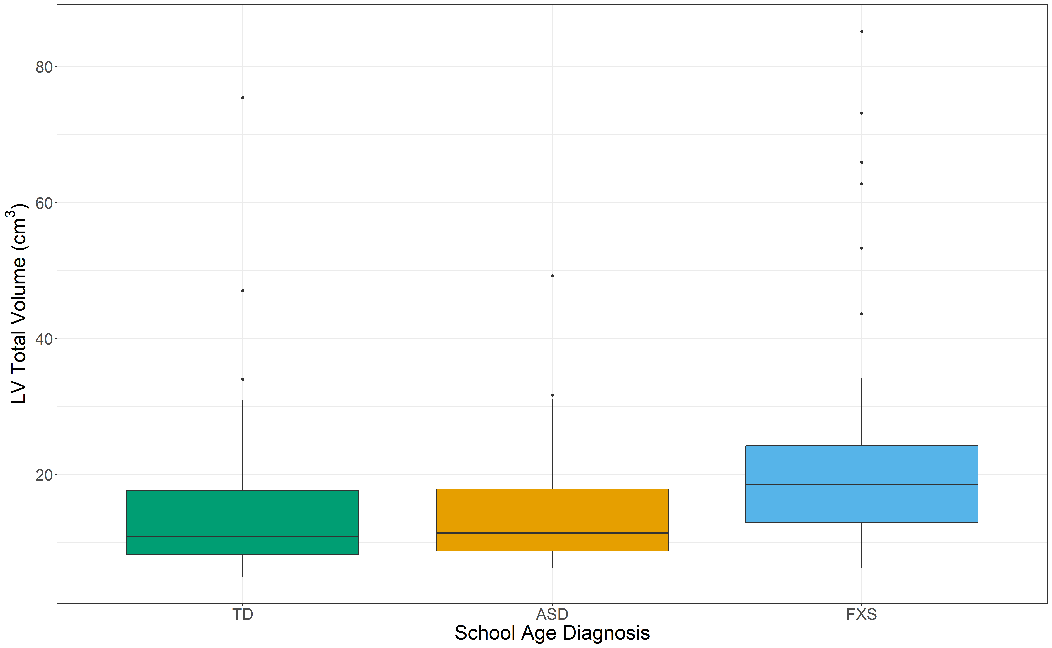

**Figure 2:** LV Volumes by Diagnosis (TD, ASD, FXS) as reported using median and IQR. Points indicate outliers according to ±1.5IQR definition.

*Regression Analyses*

The results for the regression analyses of total LV volume and laterality index, using the back-transformed models, are presented in Table 2. The back-transformed results are presented for interpretability but are identical to the log-transformed model results, presented in the supplemental materials. For LV volume, the estimates and 95% CI indicate estimated change in mean total LV volume from a one unit increase in the covariate (or a change from TD to ASD or FXS), holding all other covariates constant. Significant associations were found between diagnosis and total LV volume, with FXS having 43% higher LV volume on average compared to TD [CI: (14.64, 77.28)], controlling for TCV and age. ASD children were not found to have significant differences in mean LV volume [CI: (-25.32, 16.38)]. These differences are also seen in the least squares means for total LV volume based on the model, for the TD, ASD, and FXS groups, shown in Figure 3. These means were created by again back-transforming the log-transformed results with the exponential function. Estimates and 95% CIs for these least square means are provided, indicating that the FXS group has significant higher total LV volume then the TD and ASD groups, controlling for TCV and age. No differences in association between TCV or age and total LV volume between TD and ASD or TD and FXS, based on the interaction term results.

For laterality index, the estimates and 95% CI indicate estimated change in mean laterality index from a one unit increase in the covariate (or a change from TD to ASD or FXS), holding all other covariates constant. Significant associations were not found between index and the main effect of diagnosis [ASD – CI: (0.1366, 0.5726), FXS – CI: (-0.0624, 0.0432)]. However, significant differences between the associations in age and index were found in the FXS and ASD groups relative to the TD group [ASD*Age – CI: (0.0068, 0.0446), FXS*Age – CI: (0.006, 0.0428)]. This indicates that the index is changing significantly more towards the right side (closer to +1) in these two groups compared to TD, as the child ages.

**Table 2**: Parameter estimates and 95% confidence intervals (CI) from back-transformed LV volume and lateral ventricle regression models. Estimates in terms of estimated mean percent change in lateral ventricle outcome variable from change in covariate. For continuous covariates, change is with respect to a one unit increase, for diagnosis change is with respect to typically developing child school age, controlling for all other covariates in the model.

| Outcome | Covariate | Estimate | P-value | 95% CI |
| --- | --- | --- | --- | --- |
| LV Total Volume (cm3) | TCV (cm3) | 0.16 | 0.075 | (-2e-04, 0.0034) |
| Age (years) | 2.61 | 0.369 | (-0.0308, 0.0823) |
| ASD | -6.77 | 0.533 | (-0.2919, 0.1517) |
| FXS | 42.56 | <0.005*** | (0.1366, 0.5726) |
| TCV (cm3):ASD | -0.08 | 0.478 | (-0.0031, 0.0015) |
| TCV (cm3):FXS | -0.11 | 0.426 | (-0.0038, 0.0016) |
| Age (years):ASD | 0.91 | 0.818 | (-0.069, 0.0872) |
| Age (years):FXS | 5.15 | 0.193 | (-0.0258, 0.1263) |
| LV Lateral Index | TCV (cm3) | 0.00 | 0.477 | (-3e-04, 6e-04) |
| Age (years) | -0.02 | 0.03* | (-0.0289, -0.0015) |
| ASD | -0.01 | 0.657 | (-0.0658, 0.0416) |
| FXS | -0.01 | 0.719 | (-0.0624, 0.0432) |
| TCV (cm3):ASD | -0.00 | 0.143 | (-0.001, 1e-04) |
| TCV (cm3):FXS | -0.00 | 0.59 | (-8e-04, 5e-04) |
| Age (years):ASD | 0.03 | 0.008** | (0.0068, 0.0446) |
| Age (years):FXS | 0.02 | 0.01** | (0.006, 0.0428) |

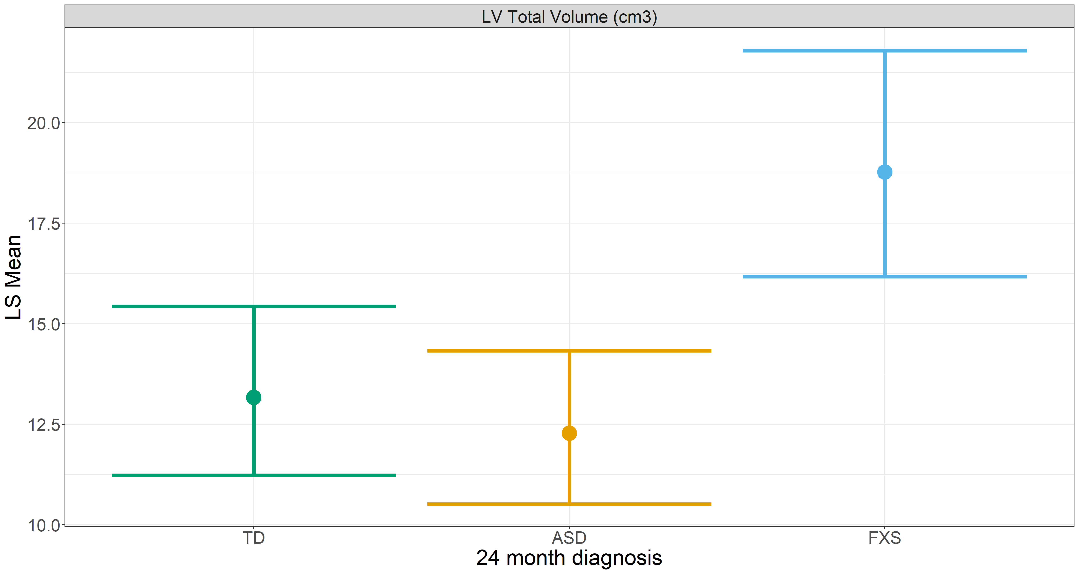**Figure 3:** Least square means for total LV volume by diagnosis group, based on back-transformed model results. Estimates and 95% CIs provided.

*Correlation Analyses*

Table 3 presents the correlation (denoted as *marginal*) and partial correlation (controlling for age) results between various behavioral measures and total LV volume in the FXS sample only. For each correlation, the estimate, p-value for the test of zero correlation, and FDR-adjusted p-value (at an FDR of 0.05) are provided, with estimates and p-values computed based on Pearson correlation. The unadjusted results indicated that there was evidence for significant marginal correlations between total LV volume and behavioral measure in the FXS group, for VABS ABC SS (p=0.025), VABS DLS SS (p=0.02), VABS Social SS (p=0.028), DAS GCA SS (p=0.048), and DAS SNC SS (p-0.023). However, none of these withstood correction for multiple comparisons at an FDR of 0.05. None of the partial correlations were significant with or without adjustment at a 0.05 level.

**Table 3**: Marginal correlation and partial correlation results between various behavioral measures and total LV volume in the FXS sample only (n=51, some missing behavioral measures).

| Behavioral measure | Correlation type | Estimate | P-value | FDR-adjusted p-value |
| --- | --- | --- | --- | --- |
| VABS ABC SS | Marginal | -0.32 | 0.025* | 0.1 |
| Partial | -0.20 | 0.181 | 0.253 |
| VABS Comm SS | Marginal | -0.27 | 0.057 | 0.114 |
| Partial | -0.14 | 0.341 | 0.367 |
| VABS DLS SS | Marginal | -0.33 | 0.02* | 0.1 |
| Partial | -0.26 | 0.074 | 0.13 |
| VABS Motor SS | Marginal | 0.09 | 0.612 | 0.612 |
| Partial | -0.19 | 0.312 | 0.364 |
| VABS Social SS | Marginal | -0.31 | 0.028* | 0.1 |
| Partial | -0.16 | 0.277 | 0.352 |
| DAS GCA SS | Marginal | -0.34 | 0.048* | 0.114 |
| Partial | -0.28 | 0.117 | 0.182 |
| DAS SNC SS | Marginal | -0.39 | 0.023* | 0.1 |
| Partial | -0.34 | 0.054 | 0.114 |

**Discussion:**

To the best of our knowledge, this study marks one of the largest comparisons of LV volumes within this specific population. The findings indicate that significant group differences in total LV volume exist among neurodevelopmental disorders when controlling for variation in age and total brain volume differences. Of note, children with FXS had ventricles that were markedly larger than other diagnostic groups. Identifying such differences in total LV volume has implications for providing insight into both normal and aberrant development of the brain, including of nearby structures such as the caudate, corpus callosum, and thalamus.

Looking specifically at FXS patients, while mean LV volumes were found to be significantly larger, this finding may have been influenced by two cases in the sample that had notably larger ventricles than other children with FXS. Figure 3 offers a visualization of the heterogeneity of LV volumes within the FXS group. However, given the large number of children in the FXS group, we do not believe that the two cases would have yielded a different conclusion. As stated, patients with FXS were found to have increased white matter and larger caudate and thalamus volumes.7 This may be an indication that several other structures within the brain, such as the lateral ventricles, are also proportionally larger if the TCVs are in fact greater.

Ventriculomegaly may be associated with impaired CSF renewal, resulting in a diminished ability to excrete toxins and purify the CSF. 1,[10] Ventriculomegaly has been implicated in the pathophysiology of disorders such as Alzheimer’s and normal pressure hydrocephalus, and it is possible that impaired CSF flow is also implicated in the pathogenesis of FXS.1 Thus, ventriculomegaly may be linked to symptoms such as attentional deficits, hyperactivity, memory impairment, and poor conversational fluency, which are known to be displayed in FXS and can present in other neurodegenerative disorders as well.

By contrast, within the ASD group, despite excess white and gray matter growth noted in the brains, the ventricles were actually smaller overall than those in the TD group. In this case, a plausible theory is that in ASD, the ventricles become compressed by the larger surrounding structures. In addition, in line with prior studies,5 localized reductions in the LV horns in children with ASD may further explain the findings. Given the important role that ventricles have in CSF circulation, their structural integrity is critical to maintaining and promoting healthy brain growth.1 Abnormalities in LV volumes, including deviations that are either larger or smaller, can potentially affect the functionality of brain structures, thereby leading to the deficits observed in these children. For instance, the thalamus is involved with sensory input and processing, which is central to the development of adaptive behavior.[11] In addition, the caudate is highly involved in goal-directed behavior and, specifically, in actions that require us to consider the potential outcome of that behavior.[12] Given what we know about the behavioral patterns within FXS and ASD, the caudate appears to be a relevant structure in the pathogenesis of these disorders. As such, it would be interesting to note in future studies if the degree of neurostructural abnormalities correlates with behavioral severity.

Deviations in LV volumes observed in individuals with ASD may be compounded by abnormalities in the ability to recycle CSF in the extra-axial space. As research illustrates, infants who develop ASD are more likely to have increased CSF in the extra-axial space. The pathogenesis behind the elevated extra-axial CSF is theorized to involve impaired mechanisms of CSF reabsorption.[13] Although the LV volumes in the ASD group were not found to be significantly different from other diagnostic groups, this finding may explain a lack of a compensatory mechanism in CSF production within the LVs to offset the impaired reabsorption in the extra-axial space.

It is also interesting to note that the variation in LV volumes appears to increase as age increases, as illustrated in Figure 3. Determining group differences in LV volumes in children who are below the age of 10 and above the age of 10 may help elucidate the age at which aberrant brain growth becomes apparent or more pronounced based on definitive neuroanatomical markers. As the ages of the children in this study span a wide range of developmental periods (3 to 14 years of age), it will be interesting to note if there is a particular age range during which abnormalities in LV growth present. Given the lack of a significant interaction between age and diagnosis, there was no evidence in the data that this is the case, though a non-linear modeling structure may be better at identifying this (e.g. spline analysis) given the wide range.

One limitation of this study is that it was conducted on only male subjects. Although both FXS and ASD are neurodevelopmental disorders that predominantly affect males, females also represent a sizable portion of the affected population. Given that FXS is an X-linked dominant disorder, its inheritance pattern affects mainly males, though not to the extent of X-linked recessive disorders. FXS affects 1 in 7,000 males and 1 in 11,000 females.[14] On the other hand, the inheritance pattern of ASD is not completely understood, though it is thought to affect males to females at a 3:1 ratio.[15] Especially considering that ASD was previously thought to affect males to females at a 4:1 ratio, there is an increased need to elucidate the pathogenesis of ASD in females. As such, in future studies, it will be important to highlight these neuroanatomical differences in developmental disorders in females as well.

Moreover, a future direction for this study may involve replicating the design with a larger sample size to further elucidate group differences in ventricular volume with increased power and reliability. As discussed with the two FXS cases that may have slightly skewed mean LV volume, it would be important to ensure that similar patterns are found and that they are representative of true means. Given that CSF plays such a prominent role in the initial development and continued maintenance of the brain, it potentially can be a focus of understanding the onset and pathogenesis of the symptoms in these disorders. Also, given that extra-axial CSF volumes have been associated with clinical outcomes in children with ASD,13 future studies can shed light on the relationship between LV volumes and specific behavioral, cognitive, and emotional outcomes in individuals with ASD and FXS. Understanding that relationship may hold important implications from a prognostic standpoint for clinicians.

Another area of interest going forward is the interconnected nature of the LV size and extra-axial volumes and how that relationship changes throughout growth. To the best of our knowledge, there are no studies quantifying extra-axial CSF volume beyond infancy in school-aged children with FXS and ASD. Furthermore, our study was limited in that it was cross-sectional in nature. While literature exists regarding extra-axial CSF volumes in infants, a comprehensive and longitudinal study can help identify changes in brain structures and the ventricular system throughout development. Pursuing this idea further, a longitudinal study that incorporates data from siblings may shed light on the degree to which genetics and epigenetics influence LV volumes and extra-axial volumes overall.

Gaining insight into and developing the ability to identify features of anomalous neurodevelopment is monumental. With such knowledge, clinicians can more effectively treat patients at an earlier age. They can also use targeted therapies that are based on identifying the impaired neuroanatomical structures responsible for specific functions. Moreover, diagnosticians may be able to use imaging techniques to identify these disorders in children with more accuracy or at an earlier age when the brain is more malleable. This may be especially important if there is concern regarding observed behavioral abnormalities or family history of neurodevelopmental disorders. If an association exists between LV volumes and specific clinical measures, neuroimaging can potentially be a predictor for clinical outcomes and everyday functioning in children with developmental disorders. On a final note, this study has implications for families of affected children in allowing them to feel more empowered in navigating care for their child and in making informed, timely management decisions.

**Supplementary Material**

To assess the effect of the FXS outliers for total LV volume (Figure 2; outliers in dots) on the transformed regression results when modeling volume in relation to diagnosis (Table 1), sensitivity analyses were conducted. First, to assess the influence of each infant on the regression results, two metrics were computed; 1) Cook’s Distance and 2) DF Beta. Cook’s Distance was computed for each infant, reflecting the change in the fitted line when that infant is removed from the regression analysis (**cite**). These values are visualized as bars in Figure S1, with infants colored based on their diagnosis. We see elevated distances within each group, with some TD infants having the largest distances, indicating the largest changes to the fitted line.

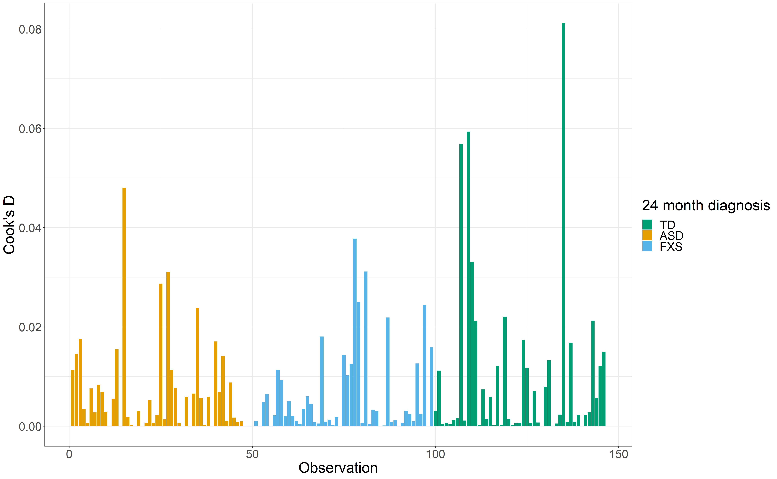

**Figure S1**: Cook’s Distance for each infant based on regression model of log total LV volume and diagnosis. Infant colored by diagnosis.

To assess more specifically the potential impact of the FXS outlier values for LV total volume on the difference observed in total LV volume between FXS and TD while controlling for TCV and age, DF Beta values for each infant were also computed. DF Beta is a measure which computes the change in the estimated regression parameter estimate when removing a given infant, standardized by the variability in the data (**cite**). These measures for the log total LV volume regression model are provided in Figure S2, for each infant and regression parameter. The results indicate large effects on the FXS main effect estimate for a small group of FXS infants, based on a DF Beta threshold of ± which is often used as a cutoff for *extreme values*. This is further seen in Figure S3, which visualized the DF Beta values for the FXS main effect, only for infants with DF Beta outside of the above threshold. This figure shows the total LV volume and DF Beta for these infants for the FXS main effect, indicating that those in the FXS group with a high positive extreme value are those with very high LV volumes (4 infants). Note that as with Cook’s Distance, a subset of TD infants also have large impacts on the results, in this case based on DF Beta, for many parameter estimates (see Figure S2).

Based on these results, the transformed total LV volume regression model was re-run, with these 4 infants with extreme values removed. The corresponding results are presented in Table S1. The results indicate that after removing these infants, FX infants have an estimated 27% higher LV volume on average compared to TD [CI: (3.33, 56.6)], controlling for TCV and age. This is a smaller percent increase then was estimated in the entire sample (43%), though it is again significant at the 0.05 level (p=0.024). The least squared means in total LV volume based on these results, for each diagnosis group with age and TCV at their sample means, are provided in Figure S3. Estimates and 95% CIs for these least squared means are provided.

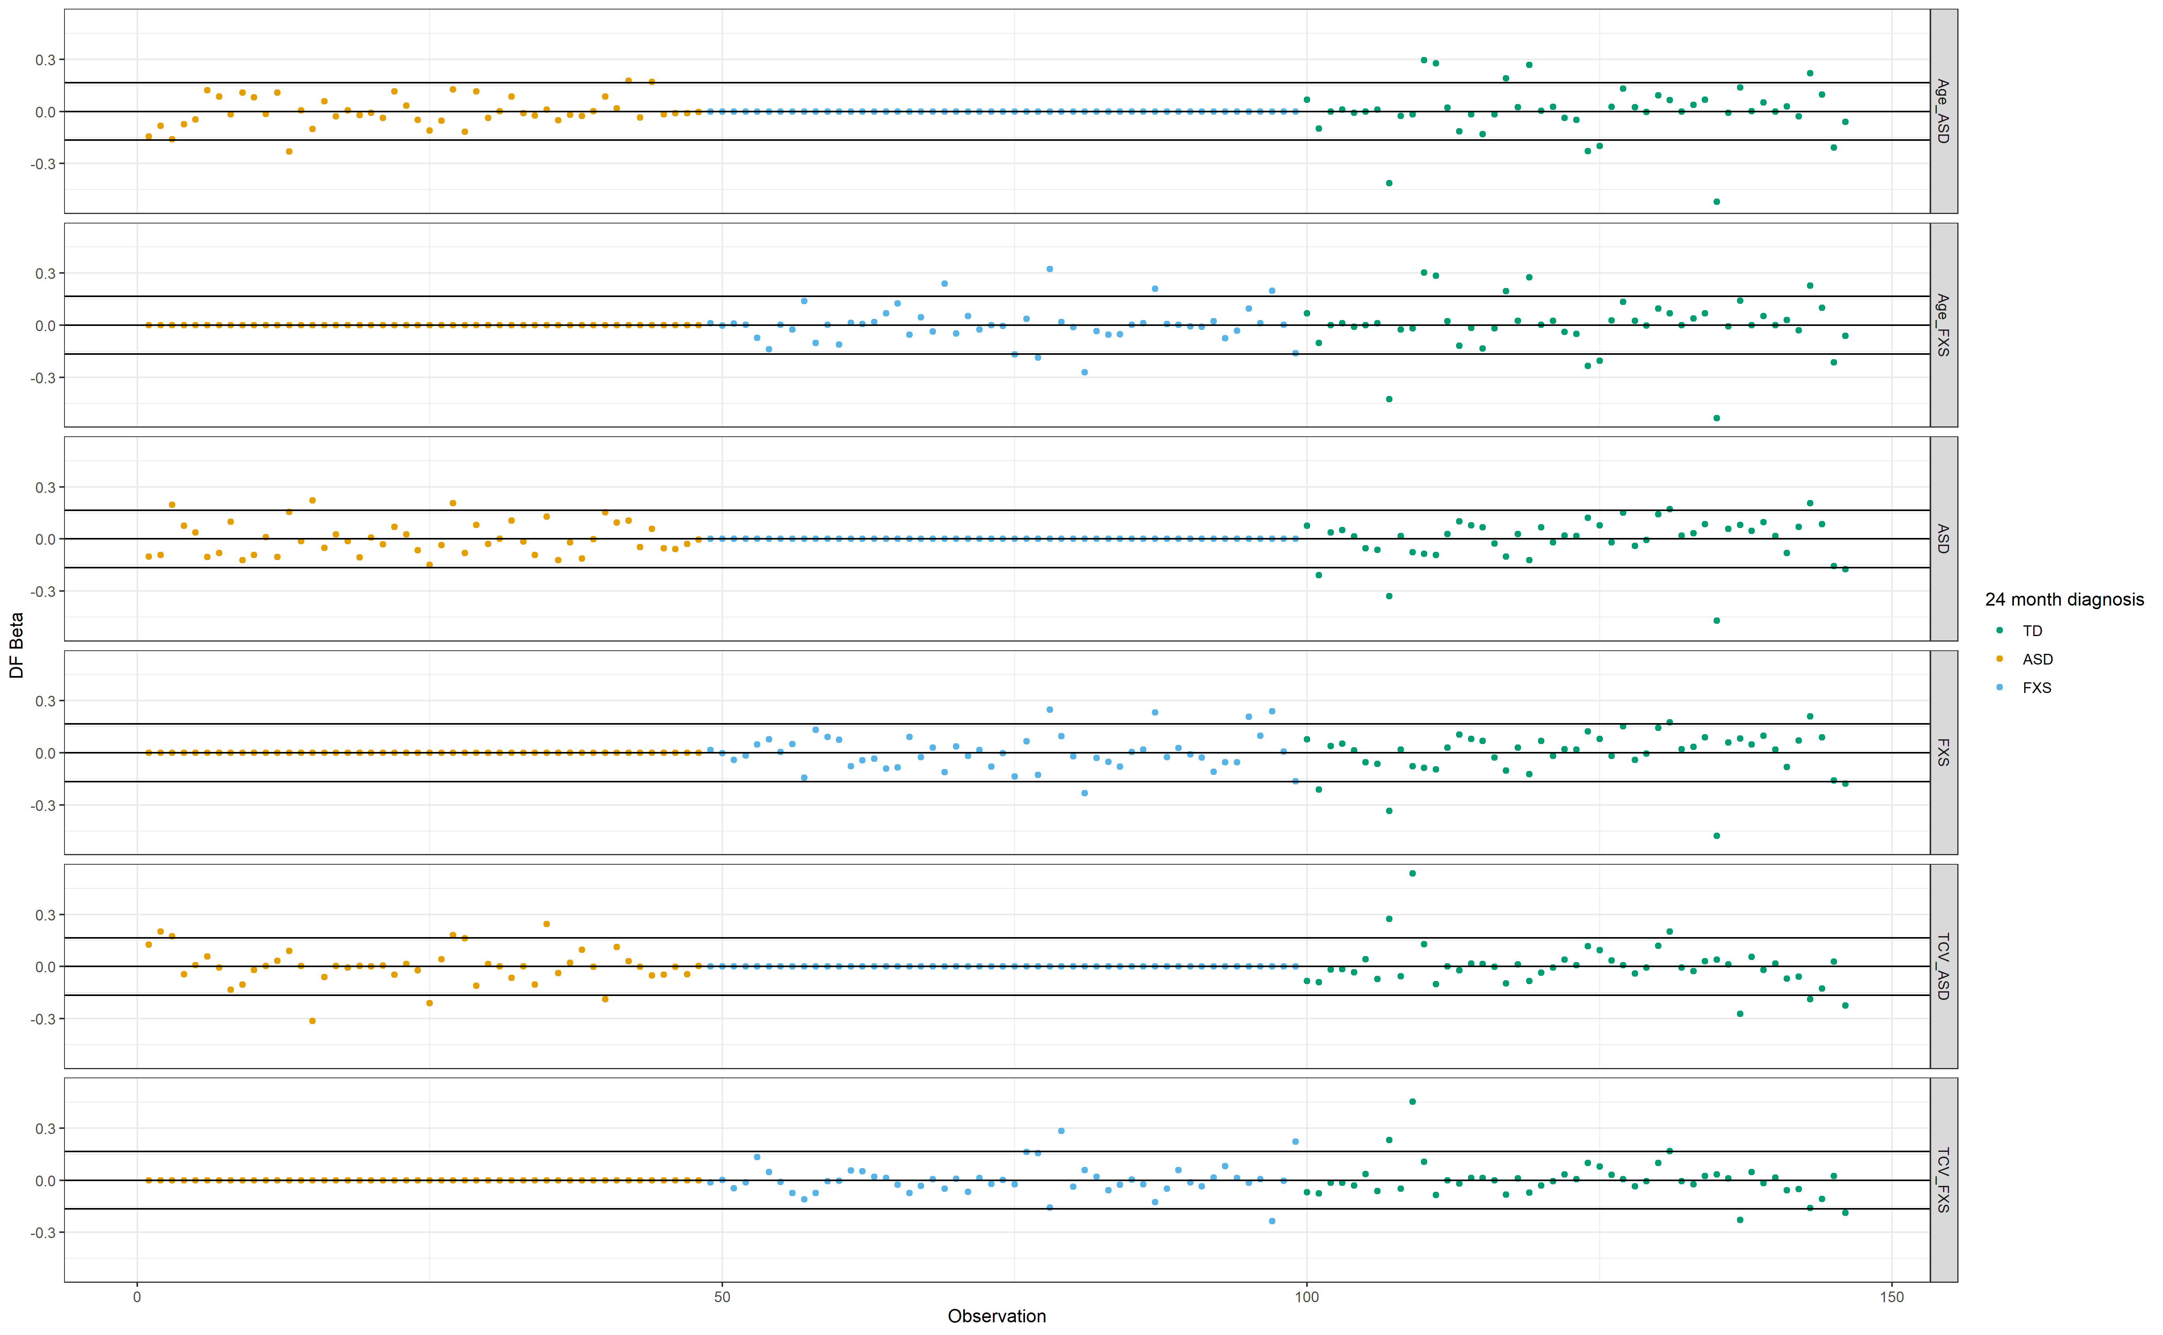**Figure S2**: DF Beta estimates for each infant, for each parameter estimates in the log-transformed total LV volume regression model. Upper and lower black indicate DF Beta threshold denoting “extreme” values

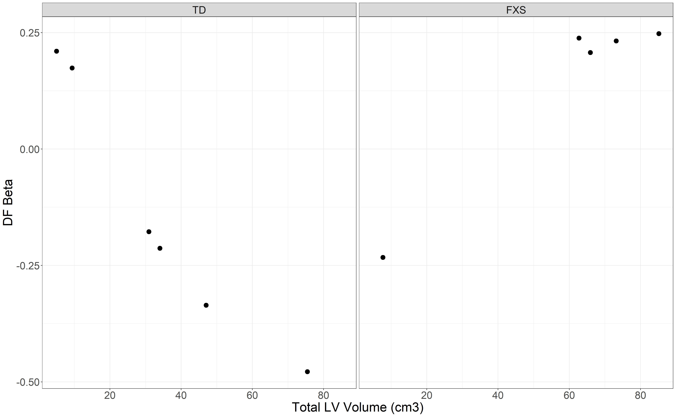

**Figure S3**: Scatterplot of total LV volume and DF Beta for FXS main effect, for infants marked as extreme values based on the DF Beta threshold for FXS main effect. Infants grouped by diagnosis.

**Table S1**: Parameter estimates and 95% confidence intervals (CI) from back-transformed LV volume regression model, after removing infants marked as extreme values in the FXS group based on their DF Beta for the FXS main effect (4 infants).

| Outcome | Covariate | Estimate | P_value | CI |
| --- | --- | --- | --- | --- |
| LV Total Volume (cm3) | TCV (cm3) | 0.16 | 0.056 | (0, 0.33) |
| Age (years) | 2.61 | 0.335 | (-2.65, 8.16) |
| ASD | -6.77 | 0.503 | (-24.17, 14.61) |
| FXS | 27.21 | 0.024* | (3.33, 56.6) |
| TCV (cm3):ASD | -0.08 | 0.446 | (-0.29, 0.13) |
| TCV (cm3):FXS | -0.03 | 0.834 | (-0.28, 0.23) |
| Age (years):ASD | 0.91 | 0.805 | (-6.16, 8.52) |
| Age (years):FXS | 1.48 | 0.688 | (-5.59, 9.09) |

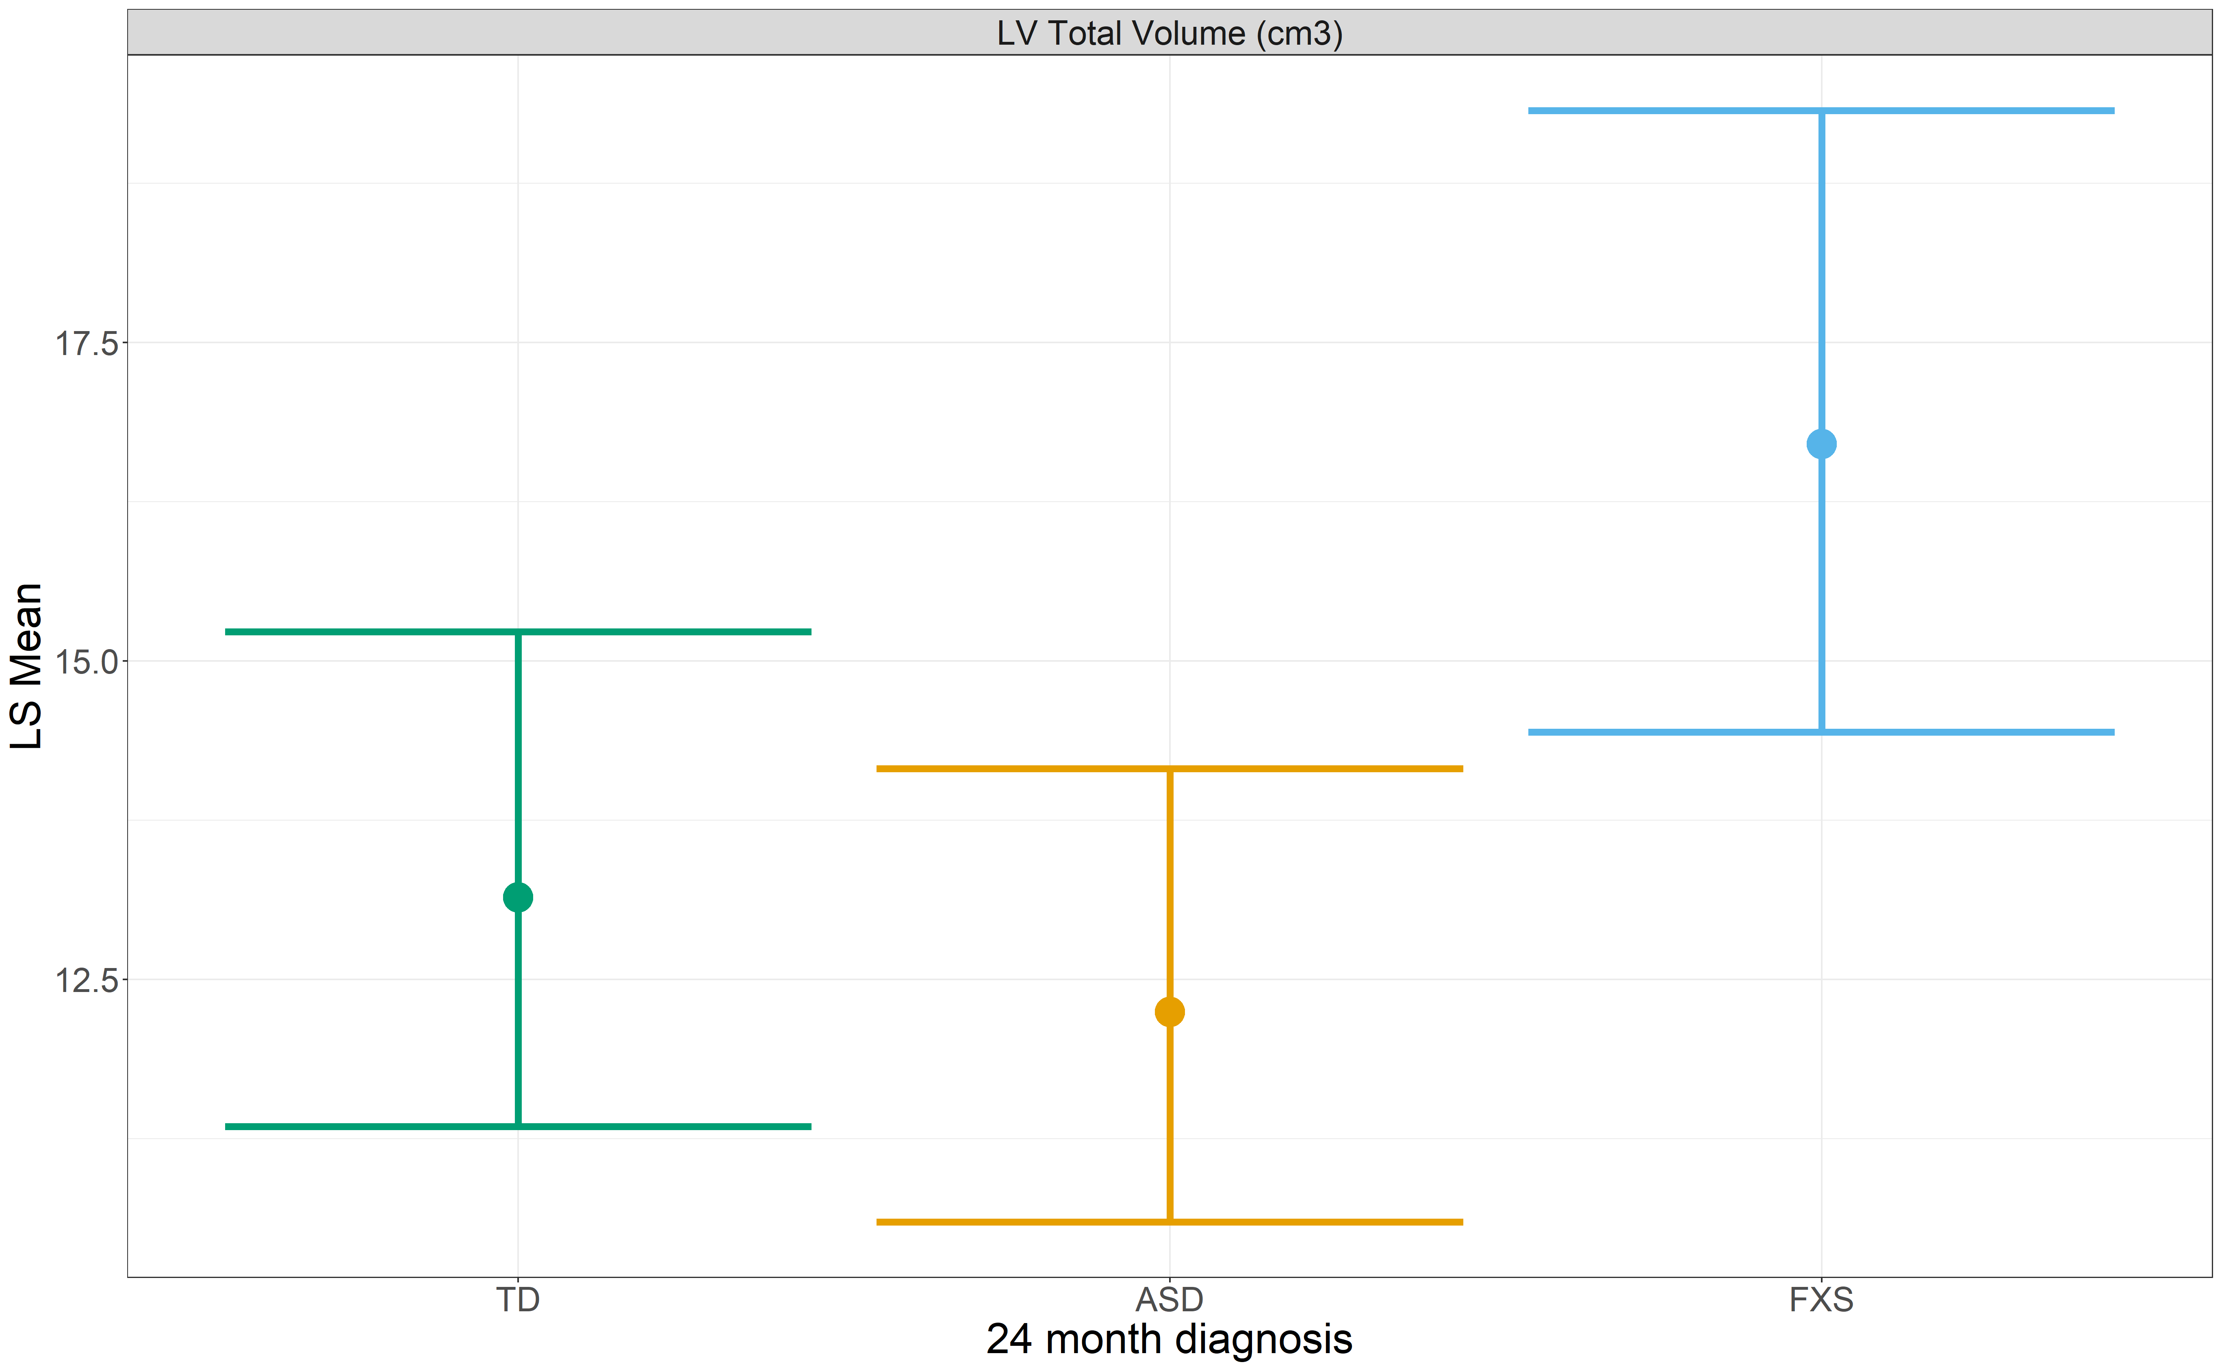

**Figure S4:** Least square means for total LV volume by diagnosis group, based on back-transformed model results after removing infants marked as extreme values in the FXS group based on their DF Beta for the FXS main effect (4 infants). Estimates and 95% CIs provided.

1. Works Cited

   Johanson CE, Duncan JA 3rd, Klinge PM, Brinker T, Stopa EG, Silverberg GD. Multiplicity of cerebrospinal fluid functions: New challenges in health and disease. *Cerebrospinal Fluid Res*. 2008;5:10. Published 2008 May 14. doi:10.1186/1743-8454-5-10
2. Lehtinen MK, Zappaterra MW, Chen X, et al. The cerebrospinal fluid provides a proliferative niche for neural progenitor cells. *Neuron*. 2011;69(5):893-905. doi:10.1016/j.neuron.2011.01.023
3. Grant R, Nozyce M. Proposed changes to the American Psychiatric Association diagnostic criteria for autism spectrum disorder: implications for young children and their families. *Matern Child Health J*. 2013;17(4):586-592. doi:10.1007/s10995-013-1250-9
4. Vidal CN, Nicolson R, Boire JY, et al. Three-dimensional mapping of the lateral ventricles in autism. *Psychiatry Res*. 2008;163(2):106-115. doi:10.1016/j.pscychresns.2007.11.002
5. Hazlett HC, Gu H, Munsell BC, et al. Early brain development in infants at high risk for autism spectrum disorder. *Nature*. 2017;542(7641):348-351. doi:10.1038/nature21369
6. Eliez S, Blasey CM, Freund LS, Hastie T, Reiss AL. Brain anatomy, gender and IQ in children and adolescents with fragile X syndrome. *Brain*. 2001;124(Pt 8):1610-1618. doi:10.1093/brain/124.8.1610
7. Eliez S, Blasey CM, Freund LS, Hastie T, Reiss AL. Brain anatomy, gender and IQ in children and adolescents with fragile X syndrome. *Brain*. 2001;124(Pt 8):1610-1618. doi:10.1093/brain/124.8.1610
8. Budimirovic DB, Kaufmann WE. What can we learn about autism from studying fragile X syndrome?. *Dev Neurosci*. 2011;33(5):379-394. doi:10.1159/000330213
9. Yushkevich PA, Piven J, Hazlett HC, et al. User-guided 3D active contour segmentation of anatomical structures: significantly improved efficiency and reliability. *Neuroimage*. 2006;31(3):1116-1128. doi:10.1016/j.neuroimage.2006.01.015
10. Del Bigio MR. Neuropathology and structural changes in hydrocephalus. *Dev Disabil Res Rev*. 2010;16(1):16-22. doi:10.1002/ddrr.94
11. Chiel HJ, Beer RD. The brain has a body: adaptive behavior emerges from interactions of nervous system, body and environment. *Trends Neurosci*. 1997;20(12):553-557. doi:10.1016/s0166-2236(97)01149-1
12. Grahn JA, Parkinson JA, Owen AM. The cognitive functions of the caudate nucleus. *Prog Neurobiol*. 2008;86(3):141-155. doi:10.1016/j.pneurobio.2008.09.004
13. Shen MD, Nordahl CW, Young GS, et al. Early brain enlargement and elevated extra-axial fluid in infants who develop autism spectrum disorder. *Brain*. 2013;136(Pt 9):2825-2835. doi:10.1093/brain/awt166
14. Hunter J, Rivero-Arias O, Angelov A, Kim E, Fotheringham I, Leal J. Epidemiology of fragile X syndrome: a systematic review and meta-analysis. *Am J Med Genet A*. 2014;164A(7):1648-1658. doi:10.1002/ajmg.a.36511
15. Loomes R, Hull L, Mandy WPL. What Is the Male-to-Female Ratio in Autism Spectrum Disorder? A Systematic Review and Meta-Analysis. *J Am Acad Child Adolesc Psychiatry*. 2017;56(6):466-474. doi:10.1016/j.jaac.2017.03.013